Report for: | Planning Policy Advisory Panel
Date of Meeting: | 6 March 2023
Subject: | New Harrow Local Plan –way forward and strategic objectives
Key Decision: | No – for information and discussion only
Responsible Officer: | David Hughes – Planning Policy Manager  Viv Evans – Chief Planning Officer
Portfolio Holder: | Cllr Marilyn Ashton – Deputy Leader of the Council and Portfolio Holder for Planning and Regeneration
Exempt: | No
Decision subject to Call-in: | No – for information and discussion only
Wards affected: | All Wards
Enclosures: | None

Section 1 – Summary and Recommendations
This report seeks to introduce the Local Plan process and key issues that will need to be addressed as part of the new Harrow Local Plan and invite comment and discussion from the Panel to assist in the scoping of the Local Plan, including its broad vision and objectives.

The report will be accompanied by a presentation.

Recommendations:
The Planning Policy Advisory Panel is requested to note and comment on the report and accompanying presentation.

Reason:
Stakeholder input into the development of the New Local Plan is essential in ensuring that the Plan reflects the aspirations and priorities of the Council and the community; the Panel is a key stakeholder in the Local Plan process. The broad vision and strategic objectives set the framework for the development of the plan and therefore the Panel’s input into this process (facilitated by this report and discussion) is sought.

Section 2 – Report

1.0 Introduction

1.1 The Council has committed to preparing a new Harrow Local Plan. This is in response to the time that has elapsed since the current Local Plan was adopted (2012 and 2013) and changes in national and regional planning policy since that time, as well as emerging issues and local priorities.

1.2 At its last meeting on 9 January 2023, the Panel considered a report in relation to the Council’s Local Development Scheme (LDS). The LDS is a rolling three-year project plan setting out all the planning documents to be produced by the local authority and the timetable for their preparation. The draft LDS considered by the Panel committed the Council to prepare a new Local Plan, with adoption scheduled for December 2025. The LDS was subsequently agreed by Cabinet on 16 February 2023.

1.3 In the context of the above, this report and accompanying presentation seek to introduce the Local Plan process in more detail and key issues that it will need to be addressed. It invites comment and discussion from the Panel to assist in the scoping of the Local Plan, including its broad vision and objectives. The discussion will also inform drafting of the new Local Plan, which will be presented to the Panel over a number of meetings in 2023 in the lead-up to agreement by Cabinet to undertake the initial consultation (‘Regulation 18 consultation’) on the draft Local Plan at the end of 2023.

2.0 Options considered

2.1 The National Planning Policy Framework emphases the role of Local Plans in the planning system: ‘The planning system should be genuinely plan-led. Succinct and up-to-date plans should provide a positive vision for the future of each area; a framework for addressing housing needs and other economic, social and environmental priorities; and a platform for local people to shape their surroundings’ (paragraph 13).

2.2 Input from elected members is central in shaping the vision of the borough through the Local Plan process and early input (such as this report, presentation and discussion) seeks to ensure any draft plan reflects this vision. The alternative option of not doing this is not considered appropriate as it may result in a draft plan that doesn’t respond to members’ vision and input and necessitate further work and delays to the process. That option has therefore been discounted.

3.0 Background – the Tiers of Planning

National Planning Policy Framework

3.1 The National Planning Policy Framework (NPPF) sets out government's planning policies for England and how these are expected to be applied. It covers both:

(a) ‘plan making’ – what regional and local plans are expected to address / achieve, the evidence required to support policies and the process for their preparation
(b) ‘decision taking’, including the weight accorded to policies in the development plan (and whether they are considered ‘out-of-date’) and default ‘national’ policies, including key ones relating to Green Belt, historic environment and flooding.

3.2 The NPPF should be used to decide applications where the local plan is absent, silent, indeterminate or where relevant policies are out of date.

Statutory Development Plan – London Plan and the Harrow Local Plan

3.3 The statutory development plan for Harrow comprises the London Plan 2021 and the Harrow Local Plan. Planning applications must be determined in accordance with the development plan unless material considerations indicate otherwise.

London Plan 2021

3.4 The London Plan (2021) was published on 2 March 2021, becoming London’s Spatial Development Strategy and part of Harrow’s Development Plan, replacing the version adopted in 2016. Where applicable, policies within the London Plan must be considered in determining planning applications (as it is part of the borough’s development plan).

3.5 The London Plan is also relevant to the preparation of the new Harrow Local Plan as the Local Plan has to be in ‘general conformity’ with the London Plan. General conformity provides some scope for local variation in local plans (i.e. its not ‘absolute’ conformity) but the London Plan drafting will determine any scope (i.e. whether a requirement is something boroughs ‘must’, ‘should’ or ‘may’ do).

Harrow Local Plan

3.6 The Harrow Local Plan currently comprises:

(a) Core Strategy (February 2012) - sets out the long-term vision of how Harrow, and the places within it, should develop by 2026 and sets out the Council's spatial strategy for delivering that vision. In particular, it identifies the broad locations for delivering housing and other strategic development needs such as employment, retail, leisure, community facilities and other uses. It also sets the context for the other policy documents that make up the Harrow Local Plan.

(b) Harrow and Wealdstone Area Action Plan (July 2013) - prepared jointly with the GLA and other partners, it sets out a comprehensive set of policies, proposals and site allocations for development within the Harrow and Wealdstone Intensification Area, which includes the town centres of Harrow and Wealdstone, the corridor between them, and the business land surrounding Wealdstone. It includes major redevelopment opportunities and supporting social and physical infrastructure, and sets out the planning framework promoting significant change, and where applicable detailed development management policies.

(c) Development Management Policies Local Plan (July 2013) - contains detailed policies that planning applications for development or land use will be assessed against. The policies are generally criteria based and focus on giving effect to the strategic objectives and policies of the Core Strategy.

(d) Site Allocations Local Plan (July 2013) - sets out the allocated sites except for those set out in the Area Action Plan. It identifies the locations and sites for specific types of development in order to ensure the vision, objectives and strategy of the Core Strategy are implemented. The broad parameters for development of each site are listed covering land use and development criteria.

3.7 The above are accompanied by an adopted Policies Map that illustrates particular land uses throughout the Borough including areas for protection such as open space and conservation areas, as well as employment and residential activities. It also identifies key sites for development (‘site allocations’).

3.8 As the Harrow Local Plan documents above were prepared over five years ago, aspects of them are considered to be out-of-date and where the London Plan has a policy also covered in the Harrow Local Plan, the London Plan policy will take precedence where there is a conflict as the London Plan was adopted more recently.

3.9 The West London Waste Plan (July 2015) is also part of the Harrow Local Plan. This is a joint Local Plan document prepared by the six west London Boroughs of Harrow, Brent, Ealing, Hillingdon, Hounslow and Richmond. The joint West London Waste Plan (WLWP) identifies and safeguards sufficient sites for waste management facilities in the area to deal with West London’s own waste up to 2031. The Plan also contains policies against which to assess proposals for waste management facilities. This plan will be updated separately.

Supplementary Planning Documents and other material considerations

3.10 Supplementary Planning Documents support policies in the Core Strategy. They are recognised in legislation. They have been subject to public consultation and approved by Executive. Supplementary Planning Documents are a material consideration in the determination of planning applications.

3.11 Other material considerations include emerging draft plans prepared under a statutory scheme. They gain weight as they reach an advanced stage of preparation but have not been examined or adopted.

4.0 Context for the New Local Plan

Achieving sustainable development

4.1 The NPPF indicates that the purpose of the planning system is to contribute to the achievement of sustainable development. The objective of sustainable development can be summarised as meeting the needs of the present without compromising the ability of future generations to meet their own needs.

4.2 The planning system therefore has three overarching objectives, which are interdependent and need to be pursued in mutually supportive ways:

(a) An economic objective
(b) A social objective
(c) An environmental objective

The presumption in favour of sustainable development

4.3 The NPPF further indicates that all plans should promote a sustainable pattern of development that seeks to:

(a) meet the development needs of their area;
(b) align growth and infrastructure;
(c) improve the environment;
(d) mitigate climate change;
(e) including by making effective use of land in urban areas

4.4 Any strategic policies within a Local Plan should, as a minimum, provide for objectively assessed needs for housing and other uses, as well as any needs that cannot be met within neighbouring areas, unless:

(a) the application of policies in the NPPF that protect areas or assets of particular importance provides a strong reason for restricting the overall scale, type or distribution of development in the plan area; or
(b) any adverse impacts of doing so would significantly and demonstrably outweigh the benefits, when assessed against the policies in this Framework taken as a whole.

What Plans should do

4.5 In the above context, the NPPF indicates the New Local Plan should:

(a) be prepared with the objective of contributing to the achievement of sustainable development;
(b) be prepared positively, in a way that is aspirational but deliverable;
(c) be shaped by early, proportionate and effective engagement between plan makers and communities, local organisations, businesses, infrastructure providers and operators and statutory consultees;
(d) contain policies that are clearly written and unambiguous, so it is evident how a decision maker should react to development proposals;
(e) be accessible through the use of digital tools to assist public involvement and policy presentation; and
(f) serve a clear purpose, avoiding unnecessary duplication of policies that apply to a particular area (including policies in this Framework, where relevant)

4.6 It is relevant to note that the Government is proposing amendments to the NPPF that will impact upon the approach to preparing local plans. Consultation closes 3 March 2023 and the outcomes of this process should be known mid-year. The implications of any final changes to the NPPF on the preparation of the New Harrow Local Plan will need to be considered and if necessary, the process, timeframes and approach revised in response. The Panel would be advised if such action was required, and potential responses put forward.

5.0 Vision and Objectives – current Local Plan

5.1 As noted above, the Harrow Core Strategy sets out the long-term vision of how Harrow, and the places within it, should develop by 2026 and sets out the Council's spatial strategy for delivering that vision. Key elements of the vision are that by 2026, there would be:

(a) A more sustainable community
(b) Comprehensive and co-ordinated regeneration activity
(c) The Northolt Road business use area will have been renewed
(d) Rayners Lane will be enhanced to one of the best examples of a classic Metroland and Art Deco Centre in outer London
(e) The leafy suburban character of the Borough’s residential areas will have been safeguarded as areas of low density, family housing.
(f) The future of Bentley Priory and the RNOH will have been secured as places of national importance
(g) Employment land throughout the Borough will have managed to preserve a supply most suitable or existing and future needs
(h) The housing needs of the borough will have been met
(i) The overall amount of waste generated in the Borough will have been reduced

5.2 The full spatial vision is included in Appendix 1.

5.3 The current Core Strategy also includes four objectives with associated measures to achieve those objectives. The four objectives are:

(a) Protect the historical and environmental features that contribute to Harrow’s character and distinctiveness as a place to live, work and visit
(b) Enhance the infrastructure, environment and other resources which make Harrow a desirable place to live, work and visit
(c) Manage the Borough’s contribution to climate change and increase resilience to flooding
(d) Adapt to population and demographic changes to meet people’s needs and quality of life

5.4 The measures associated with the four objectives are included in Appendix 1.

6.0 What’s changed?

Changes to National policy and requirements

6.1 The original National Planning Policy Framework (NPPF) was published in March 2012. The current Harrow Local Plan was considered to be in conformity with the NPPF 2012.

6.2 The Government published a completely revised NPPF in July 2018 and made further amendments to it in February 2019 and July 2021 (the current version).

6.3 As noted above, further changes are proposed to the NPPF and the new Local Plan will need to be cognisant of the potential implications of this. Many of the proposed changes are intended to make the plan making process less difficult by reducing obligations on local planning authorities.

6.4 There have also been countless changes to statutory instruments and planning regulations. These include the extension of permitted development rights (i.e. development that doesn’t require full planning permission) (a common example in Harrow being the change of use from office-to-residential) and a new Use Class Order that re-classified some of the uses, and / or include existing uses into other use classes, impacting upon the current Plan’s ability to manage changes of use. The most notable change was the introduction of the E Use Class, which now incorporates many of the previous classes within A Use Class (i.e. shops, financial and professional services, and restaurants and cafes), B1 (offices, research and development of products / processes, industrial processes) and parts of D1 (medical / health, creche, day nursery) and D2 (indoor sport, recreation or fitness) use classes.

6.5 Environment and climate change provisions and technology have changed significantly, with the introduction of legislation such as the Environment Act that includes new requirements relating to biodiversity net gain, nature recovery, air quality and waste reduction and resource efficiency.

6.6 Additionally, new requirements in relation to fire safety have been introduced in response to the Grenfell tragedy.

6.7 Further changes are proposed through the Levelling up and Regeneration Bill and the Planning and Infrastructure Bill. The Local Development Scheme (LDS) report considered by the Panel at its meeting on 9 January 2023 provided a summary of these bills and the potential risks to the local plan timetable.

London Plan 2021

6.8 As noted above, the London Plan (2021) was published in March 2021 and replaced the previous version which was amended in 2016 (the current Local Plan was prepared under the 2011 version of the London Plan). Any review of the Harrow Local Plan must be in ‘general conformity’ with the London Plan (2021).

6.9 The following are considered key policies in the London Plan (2021) which will need to be reflected or addressed in the Harrow Local Plan:

- Identifying sufficient additional housing capacity to reflect the increase in Harrow’s 10-year housing target from 5,930 homes to 8,020 homes, including the small sites target of 3,750 homes (small sites are those less than 0.25 hectares).
- Identifying areas within the borough considered suitable for suburban intensification (namely through development on small sites).
- A design led approach to determining site density, rather than applying a density matrix.
- Defining what constitutes a tall building/s within the borough and identifying areas within the borough that maybe suitable for such buildings.
- The Mayor’s threshold approach to affordable housing financial viability assessments and local flexibility with respect to affordable housing tenures.
- Identifying potential areas for industrial intensification and mixed-use development. Greater protection for industrial land including non-designated industrial land.
- Responding to climate changes, including zero carbon development.
- Determining infrastructure requirements arising from the projected population increase in the borough and the geographic spread of new housing and identifying potential locations to accommodate this new infrastructure.

6.10 The new London Plan will be considered in more detail when specific aspects of the draft Local Plan / review are considered. The above is intended to provide key headline considerations by way of background.

Harrow Evidence Base

6.11 The NPPF requires that Local Plans are based on adequate up-to-date and relevant evidence about the economic, social and environmental characteristics and prospects of the area. Much of Harrow’s evidence base was prepared prior to the adoption on the current Local Plan documents and therefore many aspects of it are arguably out-of-date.

6.12 The recent focus of work on the Local Plan review has therefore been on updating the Council’s evidence base work, with the following work completed or in the process of being undertaken:

Completed

(a) Harrow Economic Development Needs Assessment (EDNA) (July 2017)
(b) West London Strategic Flood Risk Assessment (April 2018, updated as required as dynamic online document)
(c) Harrow Strategic Housing Market Assessment (SHMA) and West London Strategic Housing Market Assessment (August 2018)
(d) West London Gypsy, Traveller and Travelling Showpeople Accommodation Assessment (August 2018)
(e) West London Small Sites Strategic Housing Land Availability Assessment (December 2018)
(f) West London Employment Land Evidence (July 2019)
(g) West London Affordable Workspace Study (early 2021)
(h) Harrow Small Sites Capacity Study (2022)
(i) Characterisation Study for Harrow (including identification of areas suitable for tall and taller buildings) (August 2021)
(j) West London Strategic Infrastructure Delivery Plan (March 2022)

Current

(k) West London ‘E Use Class’ Study (anticipated mid-2023)
(l) Harrow Strategic Housing Market Assessment (SHMA) update (anticipated March 2023)
(m) Sporting pitches (anticipated mid-2023)
(n) Net Zero Carbon study (March 2023)

7.0 Way forward

7.1 As noted above, the new Local Plan will need to set out the spatial vision and objectives for the borough in order to meet the needs of the borough in a sustainable manner. To do this, consideration needs to be given to:

(a) What is the Council’s vision for the borough?
(b) What are the objectives for the new Local Plan?
(c) What are the needs the Local Plan should be seeking to meet?
(d) What are the issues the Local Plan should address?

7.2 The presentation and discussion at the meeting will cover the above.
Ward Councillors’ comments
Not applicable – covers all wards

Risk Management Implications
Risks included on corporate or directorate risk register? No

Separate risk register in place? Yes – as part of a weekly report reviewed by the Chief Planning Officer

This report is for information and discussion only so no immediate risks arising from the report.

Procurement Implications
None – report for information and discussion only.

Legal Implications
None – report for information and discussion only.

Financial Implications
None – report for information and discussion only.

Equalities implications / Public Sector Equality Duty
None – report for information and discussion only.

Council Priorities
Please identify how the decision sought delivers this priority.
- Putting residents first.
- A Borough that is Clean and Safe
- A Place where those in need are supported.
The wide-ranging nature of the spatial plan means that the new Local Plan will contribute to all the delivery of these priories as well as the objective to Restore Pride in Harrow.

Section 3 - Statutory Officer Clearance
Chief Officer: Viv Evans
Signed off by the Chief Officer
Date: 24 February 2023

Mandatory Checks

Ward Councillors notified: NO, as it impacts on all Wards

EqIA carried out: NO

If ‘NO’ state why an EqIA is not required for Cabinet to take a decision.

Panel is not a decision-making body and report is for information only. The Plan itself will be subject to a full EqIA

EqIA cleared by: N/A

Section 4 - Contact Details and Background Papers
Contact: David Hughes, Planning Policy Manager, david.hughes@harrow.gov.uk.
Background Papers:
National Planning Policy Framework: National Planning Policy Framework (publishing.service.gov.uk)
London Plan (2021): The London Plan | London City Hall
Harrow Local Plan: Planning and Developments – Harrow Council
Call-in waived by the Chair of Overview and Scrutiny Committee
(for completion by Democratic Services staff only)
YES/ NO / NOT APPLICABLE*
* Delete as appropriate
If Yes, set out why the decision is urgent with reference to 4b - Rule 47 of the Constitution.

Appendix 1 – Current Core Strategy (2012) – Spatial Vision and Strategic Objectives

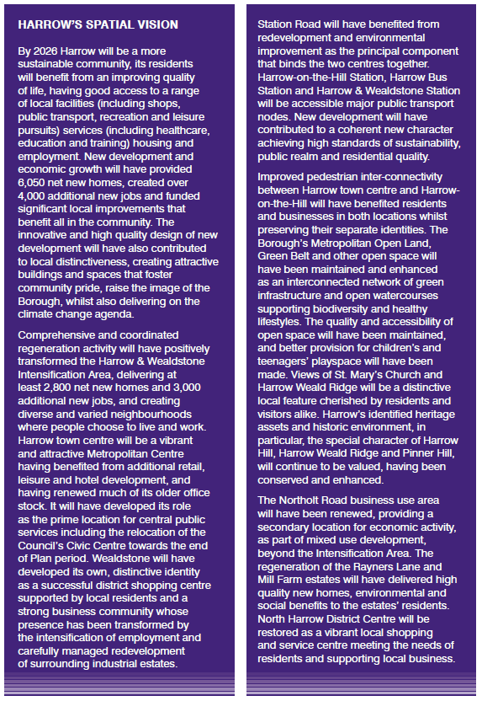

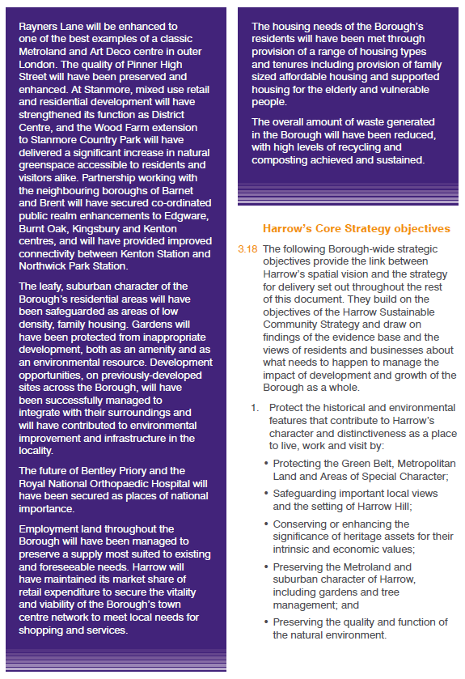

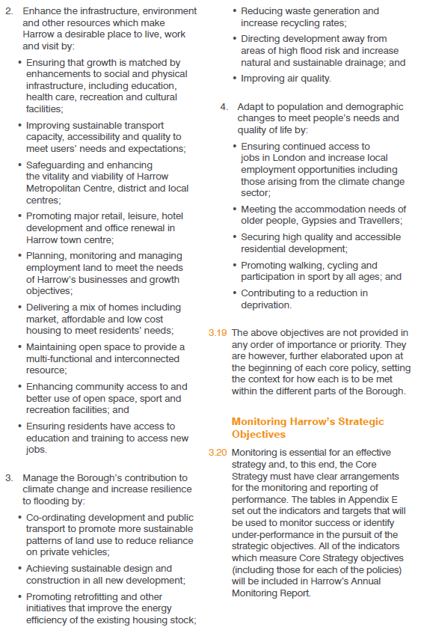

Now an Opportunity Area
See Local Plans (harrow.gov.uk)
See https://moderngov.harrow.gov.uk/documents/s179826/Local%20Development%20Scheme%20-%20Background%20Paper%20Legislative%20Risk.pdf
NPPF, paragraph 31

